Contents
Contents 1
1.Research 1
1.1 When was created 1
1.2 Versions 1
1.3 HTML Editors 2
1.4 HTML authoring 2
1.5 Different scripting languages 4
2.Planning 4
2.1 Identify size objectives and potential target audience 4
2.2 Determine material requirements for site protection 4
2.3 Determine likely user access speed, computer platform and browser 4
2.4 Determine the level of interactivity and feedback required in the site 5
2.5 Produce site structure and corresponding site map 5
2.6 Design wireframes for mobile and desktop version of your website 5

1.Research

1.1 When was created

Tim Benders-Le, an English scientist, was the primary author of HTML, he invented the World Wide Web in 1989 at CERN (Conseil Européen pour la Recherche Nucléaire). Bernes-Lee browser editor was developed in 1992, implemented in Objective-C was easy to create view and edit documents.
Now a days Word Wide Web Consortium (W3C) is the main international standards organization for the World Wide Web was founded in 1994 and currently led by Tim Bernes-Lee. Also engages in education, develop software and server. There is an open forum for discussion about the Web. Consortium is governed by its membership. Members include business, non-profit organizations, universities, governmental entitles and individuals.

1.2 Versions

First version of HTML 1.0 was released in 1993. Since them we have many versions of HTML.
HTML 2.0 published in 1995 with few additional features, to years later HTML 3.0 was included powerful features but slowed down because of archaic browsers. HTML 4.0 was published with 3 variations (strict, transitional and frameset). HTML 5 (since 2008) is used for structuring and presenting content of World Wide Web.
HTML5 introduce elements and attributes that reflect typical usage on modern web site. New APIs was introduced like JavaScript, geolocation, editable content, web audio and so much more. The most advantage of HTML5 is the backward compatible, is it possible have a old hardware or software and the system can successfully use interfaces and data from early versions of the system and compatibility with other systems. All latest versions of Google Chrome, Mozilla Firefox, Opera, Microsoft Edge support for some HTML5 functionality. Also, Android smart phones that come pre-installed browsers, iPhones and iPad all of them have a good support for HTML.

1.3 HTML Editors

HTML can be written in a MS Notepad or any normal text editor. HTML editors provide such more features to code in HTML.
HTML editors allow the users to check the syntax, insert HTML structure, short keys. Also can be translated in other languages such as XML, JavaScript etc. Is it possible to have full web site control, design, real-time update from the editor to webpage.

1.4 HTML authoring

Web authoring is the practice of creating web documents using modern web authoring software and tools. Web authoring software is a type of desktop publishing tool that allows users to navigate the tricky environment of HTML and web coding by offering a different kind of graphical user interface.
Every HTML element has a default display value, there are two display values: block and inline. Block-level elements always start on a new line. E.g., The <div> element is a block level element. An inline element does not start on a new line. E.g., <div>not start on a new line</div>
Here is an example of a simple HTML document:

<!DOCTYPE html>
<html lang="en">
<head>
<meta charset="UTF-8">
<meta http-equiv="X-UA-Compatible" content="IE=edge">
<meta name="viewport" content="width=device-width, initial-scale=1.0">
<title>Page Title</title>
</head>
<body>
<P>Hello world
</body>
</html>
<! DOCTYPE > – declares to the browser the type of document to expect. In this case a HTML document and more specifically a HTML5 document. HTML5 is the latest standard from W3C.
The <html> uses the lang attribute to indicate the document is written in English.
The <meta> tags are used to set HTTP headers to indicate that the file contains HTML and CSS text using the utf-8 character set.
To add a page title – that is seen at the top of the browser window we use the <title> tag and this is a child of the <head>
<body> tag defines the main content of the HTML document or the section of the HTML document that will be directly visible on your web page.
The dot(.) and hash(#) both of them are used as a CSS selector. Both selectors are used to select the content to set the style. CSS selectors select HTML elements according to its id, class, type, attribute, etc.
Id selector(“#”): The id selector selects the id attribute of an HTML element to select a specific element. An id is always unique within the page so it is chosen to select a single, unique element. It is written with the hash character (#), followed by the id of the element.]

<!DOCTYPE html>
<html>
<head>
<title>CSS Selector id(#)</title>
<style>
#container {
width: 200px;
height: 350px;
border: 2px solid black;
text-align: center;
}
</style>
</head>
<body>
<div id="container">
<h1 id="geeks">GeeksforGeeks</h1>
<h4 id="gfg">A Computer Science portal for Geeks</h4>
<b class="selector">CSS Selector id(#)</b>
</div>
</body>

</html>
Bold text is a CSS selector

1.5 Different scripting languages

Programming languages are compressed into smaller packages that do not need to be interpreted by another language or application. Scripting languages are written in one language and interpreted within another program; the advantage of HTML/CSS can be easy running through the most devices/browsers of the planet.

2.Planning

2.1 Identify size objectives and potential target audience
Understanding the target audience is key. Target audience is a group of consumers characterized by behaviour and specific demographics. The main group of costumers is man with 14 to 40 years old, localized in Republic of Ireland.

2.2 Determine material requirements for site protection

Computer (Windows or Mac)
Visual Studio Code (Version 1.62)
Product information and images from all-over world-wide web.

2.3 Determine likely user access speed, computer platform and browser

My product is selling across to Ireland, to know what my users access I did a little research in https://gs.statcounter.com. Most of user's access is in a mobile (57,8%) then desktop (38,98%) and tablet (3,22%).
Browsers – first is Safari iPhone (27.55%), second Chrome for Android (25,62%), third Chrome 94.0 (16,12%), Chrome 95.0 (3,7%), Safari (3,22%), Samsung Internet (3.04%), others (less than 1%).
From the above can see that mobile devices are the most used, with desktop comparing to mobile. Perhaps desktop use is increased because of the return of work.

2.4 Determine the level of interactivity and feedback required in the site

For interactivity I will make sure that my website is response, and the user can filter products based on distinct categories such as size, cost etc.
Will create a separate page called SALES, talking about us and your contact.
This level of interactivity means that the checkout area of my online store, will have to be very minimalistic divided 3 main categories (Skateboards, Clothing and Scooters).

2.5 Produce site structure and corresponding site map
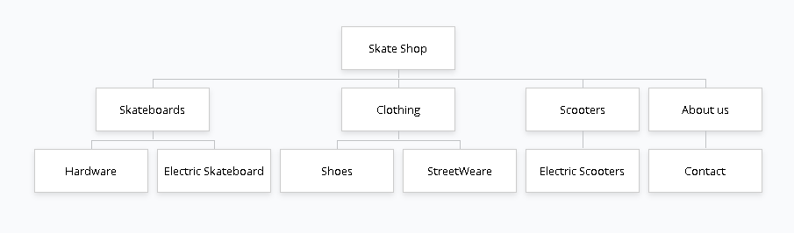
<ul>
<li><a href=”index.html”>Home</a></li>
<li> a href=”skateboards.html”>Skateboards</a></li>
<li> a href=”clothing.html”>Clothing</a></li>
<li> a href=”scooters.html”>Scooters</a></li>
<li> a href=”aboutus.html”>About Us</a></li>
</ul>

2.6 Design wireframes for mobile and desktop version of your website

